**ARCHITECTURE**

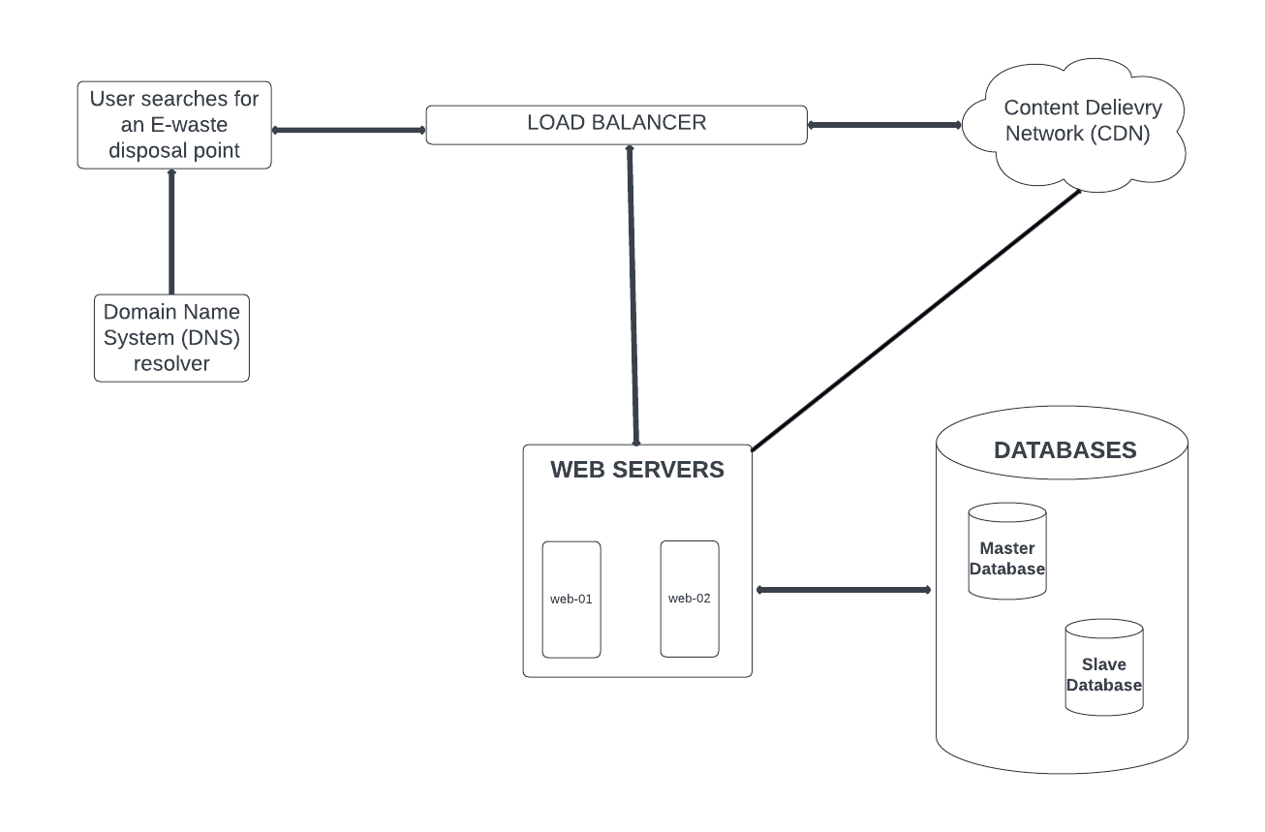

API

* Api route
  + api/v1/home :

GET: Take the client to the homepage

* + api/v1/search point

GET: Display all e-waste disposal points to user

* + api/v1/delete/<id>

DELETE: Delete a post with question posted with question_id

* + api/v1/update

PUT: Edit a search post

* api/v1/ask

POST Make a new search

* api/v1/me (Authentication required)

GET: About the user.

PUT: Edit user information

DELETE: Delete user account

* api/v1/sign-up

POST: Create a new account

* api/v1/all

GET: Display all users

Data Model

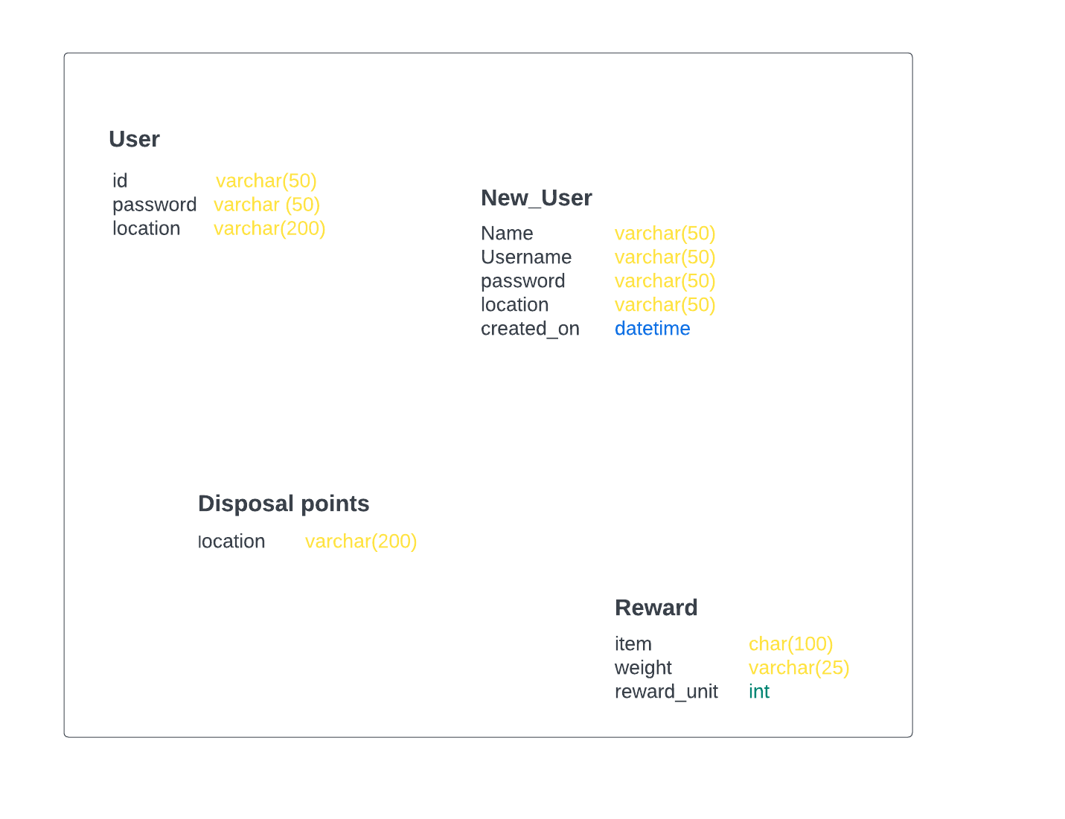

User Interface

